**TEMPERATURE MONITORING SYSTEM**

**CIRCUIT DESIGN:**

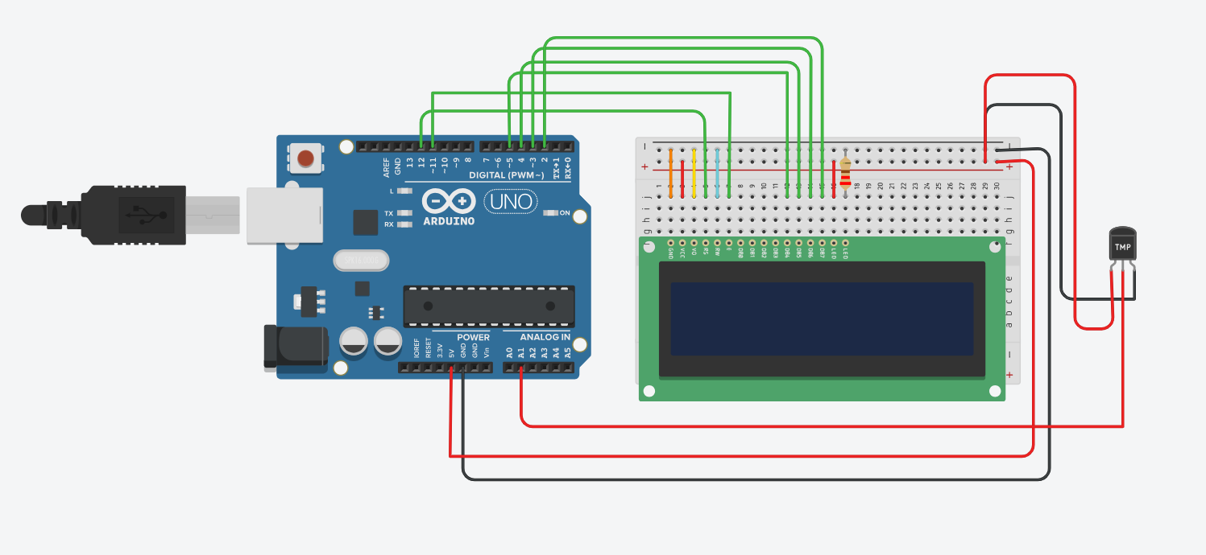

**CODE:**

#include<LiquidCrystal.h>

const int rs = 12, en = 11, d4 = 5, d5 = 4, d6 = 3, d7 = 2;

LiquidCrystal lcd(rs, en, d4, d5, d6, d7);

float celsius;

int temp = A1;

void setup() {

pinMode(temp, INPUT);

lcd.begin(16, 2); // Initialize LCD

}

void loop() {

int sensorValue = analogRead(temp);

float voltage = sensorValue * (5.0 / 1023.0); // Convert to voltage (0-5V)

// Convert the voltage to Celsius (500mV at 0°C, 20mV per °C)

celsius = (voltage - 0.5) * 100.0;

lcd.setCursor(0, 0);

lcd.print("Temp: ");

lcd.print(celsius);

lcd.print(" C");

delay(1000);

lcd.clear();

}

**OUTPUT DEMONSTRATION:**

